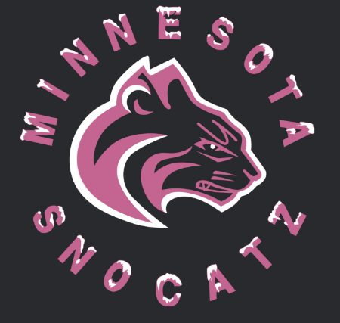
2020-2021
Withdrawal Fundraising Request Form
MN SnoCatz provide various opportunities during the year for players to help offset the cost of playing softball through fundraising. These fundraising opportunities are strictly voluntary. The dollars earned through the fundraising opportunities may be withdrawn using this form. A few examples of expenses that fundraising dollars can be used for include softball equipment purchases, training and lessons outside the MN SnoCatz organization (not tuition), or travel expenses. A receipt for the expense must accompany this request form and have a date between 8/1/2020 – 6/30/2021. If your monthly tuition is not current, fundraising money will be applied to your outstanding balance first. All requests and receipts must be submitted no later than June 30th, 2021. Any amounts not requested by June 30th will be forfeited. Requests can be submitted at any time if fundraising money is available and will be processed within 2 weeks of submitting. Request forms can be given to Stacy Ernst (MN SnoCatz Treasurer) or placed in the black payment box just inside the door at the Cage. Any questions, please email me at mnsnocatzad@gmail.com.

Player Name ____________________________________

Amount Requesting ______________________________

Your Name _____________________________________

Address to Mail Check ____________________________

_______________________________________________

RECEIPT(S) MUST BE ATTACHED FOR ANY WITHDRAWL REQUEST!

